Module 5: Ansible Assignment – 2
Tasks To Be Performed:
1. Create a script which can add text “This text has been added by custom
script” to /tmp.1.txt
2. Run this script using Ansible on all the hosts

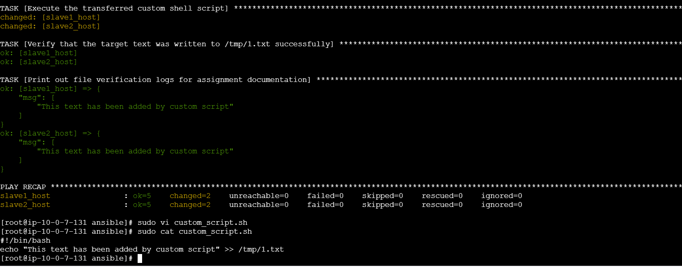
---
# Task 2: Orchestrate script deployment and execution across all cluster hosts
- name: Deploy and Run Custom Script on All Hosts
hosts: all
become: true
tasks:
- name: Copy the custom script to the remote hosts tracking paths
copy:
src: ./custom_script.sh
dest: /tmp/custom_script.sh
mode: '0755' # Grants vital execution permissions (rwxr-xr-x)

- name: Execute the transferred custom shell script
command: /tmp/custom_script.sh
changed_when: true

- name: Verify that the target text was written to /tmp/1.txt successfully
command: cat /tmp/1.txt
register: file_contents
changed_when: false

- name: Print out file verification logs for assignment documentation
debug:
msg: "{{ file_contents.stdout_lines }}"

